Curriculum vitae

afrin islam

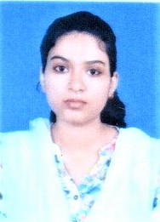
C/O: INZAMAMUL HAQUE,
BLOCK-D, FLAT- 2F,
SUGAM SERENITY, RAJPUR SONARPUR(M) SOUTH24 PARGANAS,700103.
MOBILE NO: (+91)9163520614
Email id: afrinislamjuly9@gmail.com
FATHER’S NAME: ANISUL ISLAM
Date of birth: 03/07/1998
REFERENCES: N.A.

PROFESSIONAL OBJECTIVE:
To secure a position as a teacher and utilize my dedication to foster quality education required for a child’s development.

SCHOLASTICS PROFESSIONAL SKILLS
- Languages: Native proficiency in Bengali. Relative proficiency in English and Hindi.

- Software: MS Office (including advanced excel and MS access)
- Courses: Completed Certificate in Information Technology Application from Sonarpur Youth Computer Training Centre and currently pursuing Diploma in Information Technology Application.

- Completed MA in English from Swami Vivekanand Subharti University securing an aggregate of 66.40% in 2022.

- Completed BA in General studies from Hooghly Womens’ College affiliated to University of Burdwan securing 40 % as aggregate marks in 2020.

- Completed class XII(WBCHSE) from Al-Ameen Mission [Khalatpur High Madrasah] with an aggregate mark of 74.8% in 2016.
- Completed class X (WBBSE) from Pandua Radharani girls High School with an aggregate mark of 53.3% in 2014.

I hereby declare that the information provided in this document is true to the best of my knowledge.
Date: 03.08.2023

